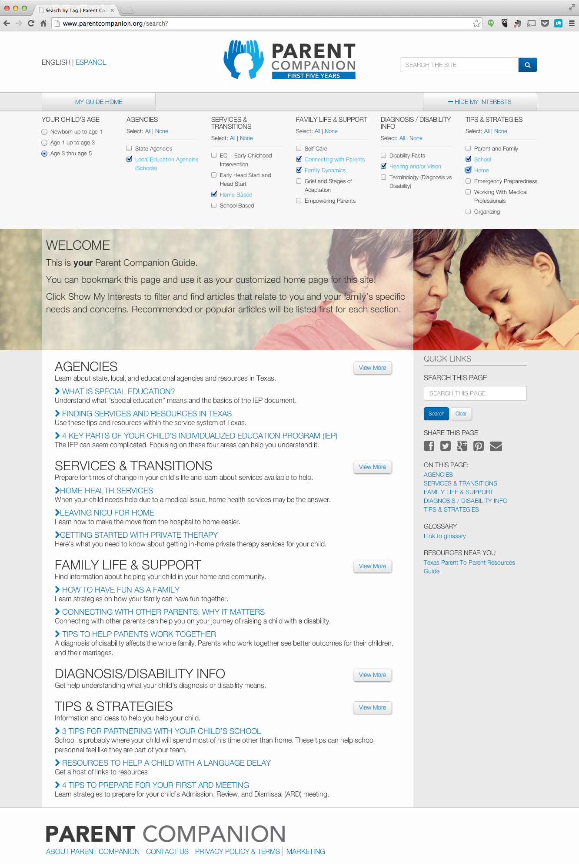
Looking for a comprehensive resource for parents of children with disabilities?
You are not alone.
The Parent Companion - First Five Years is a website that connects Texas parents of children from birth through 5 years of age to information, inspiration, and resources. The site is intended as a guide through the complex world of services and everyday scenarios encountered when raising a young child with a disability.

Find what you need when you need it.
The Parent Companion offers a custom search function to narrow down the abundant resources available to parents. Filter down by:
- The child’s age
- Agencies
- Services and transitions
- Family life and support
- Diagnosis/Disability
- Tips and strategies

Parents can also bookmark this page and use it as a customized home page for this site.
Click “Show My Interests” to filter and find articles that relate to directly to a family’s specific needs and concerns. Recommended or popular articles will be listed first for each section.
Start exploring the wealth of resources at
www.parentcompanion.org

