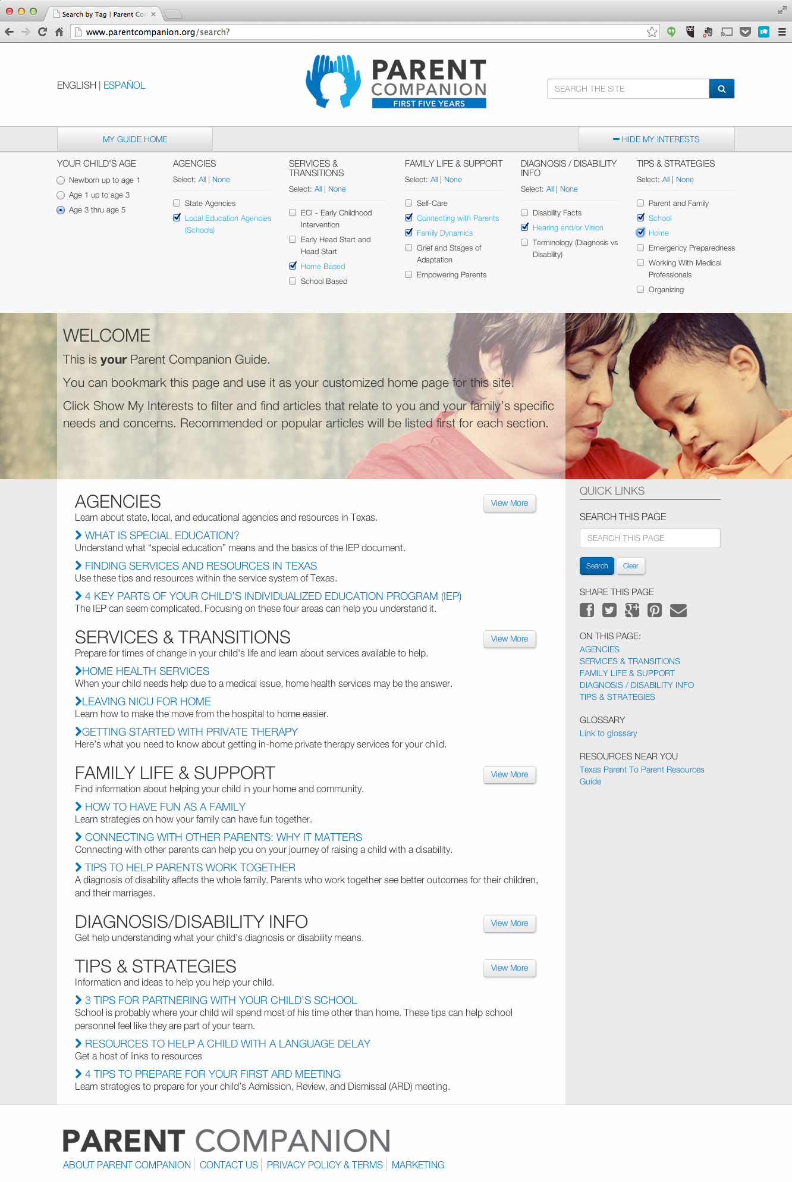
Raising a child diagnosed with a disability can be overwhelming.
You are not alone.
The Parent Companion - First Five Years is a website that connects Texas parents of children from birth through 5 years of age to information, inspiration, and resources. The site is intended as a guide through the complex world of services and everyday scenarios you encounter when raising a young child with a disability.

Find what you need when you need it.
The Parent Companion offers a custom search function to narrow down the abundant resources available to you. Filter down by:
- Your child’s age
- Agencies
- Services and transitions
- Family life and support
- Diagnosis/Disability
- Tips and strategies

You can also bookmark this page and use it as your customized home page for this site.
Click Show My Interests to filter and find articles that relate to you and your family’s specific needs and concerns. Recommended or popular articles will be listed first for each section.
Start creating your home page at
www.parentcompanion.org

